**Entity Relationship (ER) Diagram – Sales and Analytics System**

This ER diagram represents the relational structure of the **Sales and Analytics System for Salase Industries**, designed to manage and analyze sales operations, customer behaviors, and agent performance in an FMCG (Fast-Moving Consumer Goods) environment.

It includes five key entities:

1. **Customers** – Contains customer details such as name, contact info, and joining date.
2. **Products** – Stores product catalog information like category, price, and stock level.
3. **Sales** – Captures transactional details, linking customers to products with quantity and amount sold.
4. **SalesAgents** – Records the details of employees responsible for handling sales in various regions.
5. **Agent_Sales** – A mapping table that connects each sale to the responsible sales agent.

**🔗 Relationships**

* Each **Sale** is linked to one **Customer** and one **Product**.
* **SalesAgents** are connected to **Sales** through the **Agent_Sales** bridge table, allowing multiple agents to be assigned to various sales.
* The **Products** and **Customers** tables are connected directly to the **Sales** table via foreign key

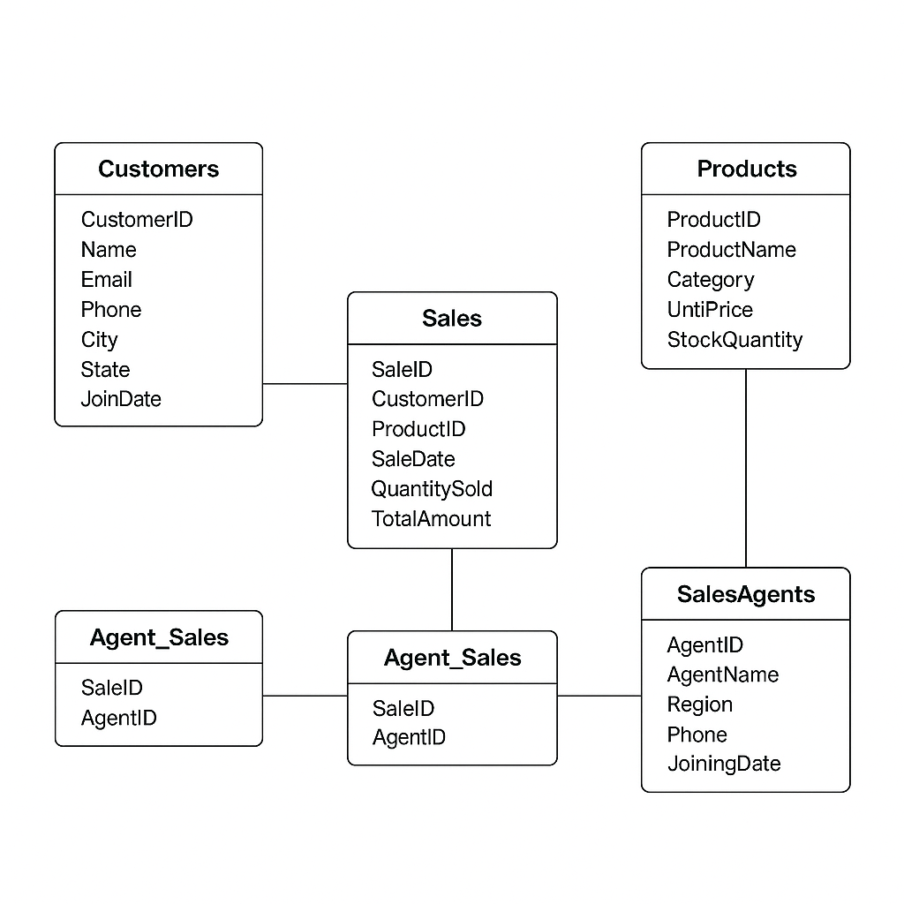

**📌 Conclusion**

This ER diagram lays the foundation of a structured and normalized relational database. It ensures data consistency, supports analytical queries, and improves the scalability of reporting systems. With clear entity connections and logical foreign key constraints, the system is optimized for tracking sales metrics, analyzing product performance, and evaluating customer and agent interactions. This model serves as the backbone for generating powerful SQL insights and business decisions for Salase Industries.